Introduction
This project focuses on applying Dijkstra’s shortest path algorithm to an urban transport network to identify optimal emergency routes from hospitals to critical locations. By modeling the city as a weighted graph, emergency planners can quickly identify the fastest response paths and adapt to dynamic traffic conditions.

Dataset Description
The dataset used in this project is a synthetic urban transport dataset, designed to simulate real-world city road networks.

Nodes (Locations)
- Hospitals (2): Hospital_A, Hospital_B
- High-risk zones (3): School, Market, Factory
- Other locations: FireStation, PoliceStation, Mall, Residential Area, Intersection
Total nodes: 10

Edges (Roads)
- Each edge represents a bidirectional road
- Edge weights represent travel time in minutes
- Weights are assigned based on assumed traffic density and distance
The dataset ensures:
- All nodes are connected
- No isolated locations exist
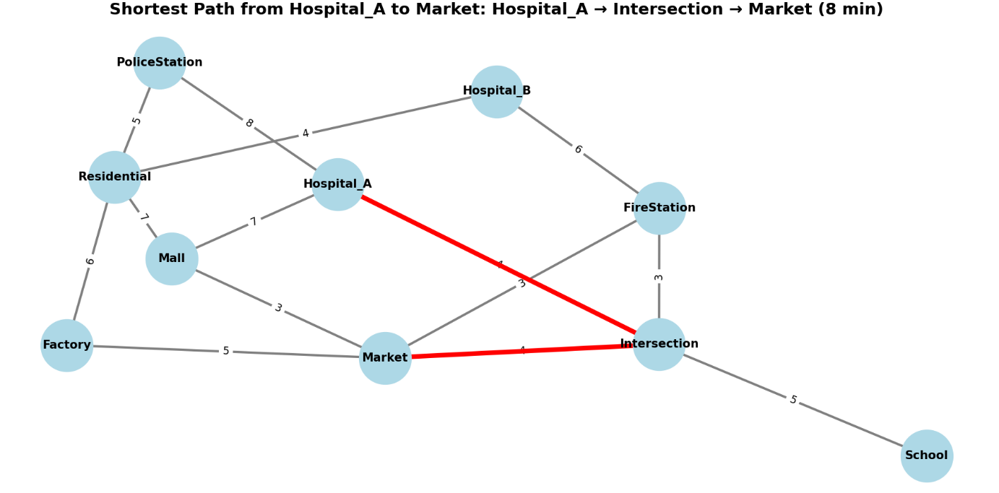

Data Preprocessing
Since the dataset is synthetically generated, minimal preprocessing is required. The following steps were performed:
- Graph Construction
  - Locations were represented as nodes
  - Roads were represented as weighted edges
- Validation Checks
  - Ensured graph connectivity
  - Verified that all weights were positive (required for Dijkstra’s Algorithm)
- Traffic Simulation
  - Road congestion was simulated by increasing edge weights
  - Blocked roads were represented by significantly increasing travel time

Model & Evaluation

Model Used
- Dijkstra’s Algorithm
- Source nodes: Hospital_A and Hospital_B
- Objective: Minimize total travel time to all other nodes

Key Results
- Hospital_A provided faster access to schools and markets
- Hospital_B was closer to industrial zones (factory)
- Congested roads resulted in automatic rerouting with increased response time

Discussion on Results
The results show that graph-based routing significantly improves emergency response planning. The visualization clearly highlights optimal paths, allowing decision-makers to identify critical routes instantly.
When a key road segment was congested, the algorithm successfully identified alternative routes, demonstrating adaptability. This confirms that integrating real-time traffic data can further enhance emergency planning during peak hours.
Comparing two hospitals revealed that location plays a crucial role in response efficiency, supporting the need for decentralized emergency facilities in urban areas.

Conclusion
This project successfully demonstrates how Dijkstra’s Algorithm can be applied to optimize emergency response times in urban transport networks. By modeling the city as a weighted graph, emergency services can identify optimal routes, adapt to traffic congestion, and prioritize critical areas efficiently. The approach is scalable and can be enhanced by integrating real-time traffic and GPS data, making it highly suitable for smart city applications.

